From the Rabbi’s Desk
Rabbi Manes Kogan
Hillcrest Jewish Center

Hold On to What is Dear!
D’var Torah for the Second Morning of Rosh Hashanah
5786
With appreciation to my colleague and friend, Rabbi Claudio Kupchik
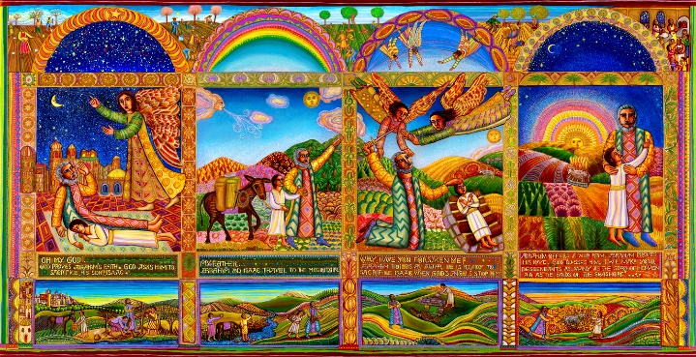
The Binding of Isaac, or Aqēḏaṯ Yīṣḥaq, in this morning’s Torah reading is a story from Chapter 22 of the Book of Genesis. In the biblical narrative, God orders Abraham to sacrifice his son, Isaac, on a mountain in the region of Moriah. As Abraham begins to comply, having bound Isaac to an altar, he is stopped by an angel of God; and a ram appears to be slaughtered in Isaac's stead, God commends Abraham's pious obedience to offer his son as a human sacrifice. At the end, Abraham and Isaac return to their servants, and they depart together for Beer-Sheba.
In a more humoristic version of the story (which shows that people can find humor in everything), Abraham took his son Isaac to the mountain following God's command. He tied up his son, and when he was holding up the knife to kill him, he heard God's voice saying, “Abraham! Abraham, do not raise your hand against the boy, or do anything to him, for now I know that you fear God.” Then, when Abraham and Isaac returned to the servants, they asked Isaac: “So, how did it go?” To which Isaac replied: “Thank God I am a ventriloquist!"
Now, humor aside, the Binding of Isaac is among the most complex and difficult texts in Jewish literature. Literally, entire libraries were written on this short story and believe me when I tell you that people keep arguing about the exact meaning of these few verses.

According to Maimonides, for example, the story demonstrates the limit of humanity's capability to both love and fear God.

Rabbi Ari Kahn argues that “Isaac's death was never a possibility – not as far as Abraham was concerned, and not as far as God was concerned. Isaac was to be ‘raised up as an offering,’ and God would use the opportunity to teach humankind, once and for all, that human sacrifice, child sacrifice, is not acceptable.”

According to Yael Feldman, the story of Isaac's binding, in both its biblical and post-biblical versions, has had a great impact on the ethos of altruist heroism and self-sacrifice in modern Hebrew national culture.

These are just a few of the Jewish takes on the story, notwithstanding the many literary, political, and psychological analyses.

Today, I would like to share a new insight, which my colleague and friend Rabbi Claudio Kupchik shared with me one day when we smoked cigars together.

Abraham is the "Father of Monotheism," the first to believe in and worship one God, setting the foundation for the Abrahamic religions of Judaism, Christianity, and Islam. Abraham's unwavering faith is demonstrated in the Book of Genesis by his willingness to sacrifice everything for a higher purpose, in this case, sacrificing his own son for the sanctification of God’s name.

For the sake of his belief, Abraham abandons his homeland, he suffers famine and ingratitude and expels Hagar and his son Ishmael. For the sake of his faith, Abraham goes to war, argues with Sarah, and even with God Himself over Sodom and Gomorrah.

Finally, for the sake of his faith, Abraham is ready to sacrifice his own son.

And then comes God and tells Abraham - and now I am paraphrasing Rabbi Kupchik, who is paraphrasing God (God, please forgive me and Rabbi Kupchik for paraphrasing You): ‘Abraham, don’t do it! I don’t want you to sacrifice your son on the altar of your belief, your faith, your values.’

In other words, God might be very proud of Abraham for keeping to his faith and values but doesn’t want him to prove his point at the expense of his son. God is saying to Abraham: You can hold onto your faith, and you can still hold onto your son. It is not one or the other.

Dear friends, we live in difficult times (I spoke about it yesterday). Family relationships and friendships are being sacrificed on the altars of beliefs, faith, and values.

Tovia Smith, an award-winning NPR National Correspondent based in Boston, who has spent more than three decades covering news around New England and beyond, reported recently on America's current political polarization.

In her article 'Dude, I'm Done': When Politics Tears Families and Friendships Apart, Tovia Smith quotes a recent survey that shows just how much the nation's bitter political divide is causing social splintering and taking a toll on friendships. Even decades-long relationships have been caving under pressure, giving new meaning to "social distancing."

As a rabbi, I am privy to how family ties and friendships have been affected by political differences; how otherwise loving and caring people believe that their differences with parents, children, siblings, and lifelong friends, are ones of basic morality, core values and character, and that, in their own assessment, they cannot be overlooked.

The story of the binding of Isaac, Aqēḏaṯ Yīṣḥaq, reminds us that you can hold to your values, to your core beliefs, and to your loved ones. God’s message to Abraham is clear: Do not raise your hand against the boy. You don’t have to sacrifice your family and your friends on the altar of your values, notwithstanding how pure and sublime they are.

Don’t give up on your family, don’t give up on your friends, don’t give up on the State of Israel, don’t give up on the United States of America, don’t give up on your fellow congregants, and yes, don’t give up on the values you hold dear, on your moral compass, on your sense of right and wrong. Try to reconnect with your heart, and you will find the truth there. Hold on to the conflict; resist the temptation to choose family and friends over values, or values over family and friends. I am not saying it is easy, but it is possible. Abraham didn’t think it was possible, and God proved him wrong. And speaking of God, here is one more reason not to give up. We are all far from perfect, and God doesn’t give up on us.

Unlike Abraham, I am afraid we don’t have an angel flying around, who will stop us when we raise the knife, who will call us to reason before it is too late. It is up to us, up to each of us.

This is my 20th High Holy Days at Hillcrest Jewish Center. By now, you should know that I prioritize relationships over ideas. Both are important, and very rarely are we asked to choose between the two. As I said before, I believe if you are smart, you can hold onto both, but in doubt, I say choose to stay connected.

And speaking of staying connected, please try to connect with me as I pray…

Master of the universe; help us remain connected to the people we love, to the ideas we hold dear, and to You. We are overwhelmed by confusion and uncertainty. We turn to You for comfort and strength.

At times we feel broken in spirit, body or soul. You have been with our ancestors through many challenging times. Please be with us as well, dear God, and make us whole again.

We promise to hold fast to the people we love, to hold fast to hope for better days, for our country, for the State of Israel, for our world. This too shall pass. Hold fast to us as well, beloved God.
As we begin a new year, we ask You to bless us and all our loved ones with a year of connections and hope, with a year of peace and tranquility, with a year of health and meaning, with a good and sweet year.

Amen

https://en.wikipedia.org/wiki/Binding_of_Isaac
https://www.npr.org/2020/10/27/928209548/dude-i-m-done-when-politics-tears-families-and-friendships-apart

