From the Rabbi’s Desk
Rabbi Manes Kogan
Hillcrest Jewish Center

D’var Torah for the Second Morning of Rosh Hashanah
5778
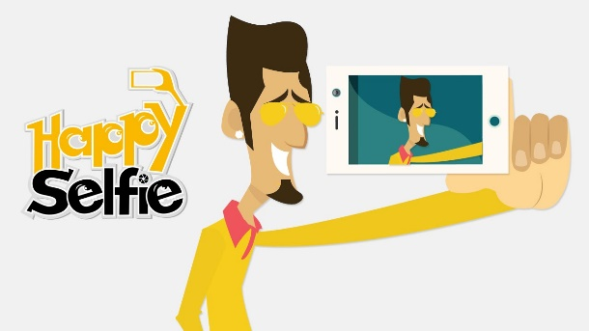
I curate my perfect social media life.
You won’t find a single negative Tweet of Facebook update. Only happy things, a momentous occasion or another achievement that would make my Asian parents proud.
You won’t read about the relationship status changed for the hundredth time, or the fact that I can’t find help to fight the monsters inside my head.
No pictures of lonely dinners or the instant noodles and chocolate bars that I shouldn’t eat.
A bouquet for our anniversary and romantic candle-lit dates; but never the tear-streaked faces and arguments late into the night, two lovers hurting each other with words sharper than knives.
You won’t find snap-chats of body parts that I am unhappy about, nor a selfie without any make-up on.
Over 3000 followers but a best friend who lives 5 minutes away, ignored.
Photos of family trips and home cooked meals; but no one sees that right after the shutter clicks, everyone turns back to their phones, more interested in scrolling through the lives of other people than to talk to each other.
So many connections but not a single one genuine.
Validation and self-worth measured by the number of likes, retweets, followers and shares.
Endless pings and buzz from the synthetic glow of various screens, but still so lonely….
The above words by Iaremyne, a young Asian woman, who confesses “I wish I was the person my social media says I am,” reflect a sad reality many of us know too well: there is a huge discrepancy between the lives many of us share on social media and the real lives we live.
Portraying being someone we are not, exaggerating good traits, and downplaying or hiding our bad ones, is a very old pastime. However, the pervasive nature of social media and the ease and inexpensiveness with which almost everyone in the world can share with well-known friends and total strangers every single detail of their lives, transforms the above pernicious pastime into an epidemic.
As Jade, a frequent writer on elitereaders, an entertainment website that offers viral articles and media sharing, writes “Nowadays people seem to be obsessed with showing off their lives on social media so the whole world will know they live a perfect, happy life. After all, what's the point of being happy if you're not going to post it? If you're going somewhere interesting, you're required to post a photo online as an evidence of your awesome experience or else the world will think it didn't happen. Not to mention, the grand announcement on Facebook seems to be more important than the actual event. First dates must be announced with pictures of the great-looking partner. Photos taken during the date are more important to show your friends how cute was your date, instead of focusing on the quality and personality of the person you dated with. Single people begin to resent seeing romantic couples on their newsfeeds because it serves as a constant reminder that they haven't found someone yet while everyone on Facebook are having the perfect relationships. It's quite easy to forget that people only post their best moments online and prefer to hide away the worst ones.”
And she concludes, “Maybe you haven't noticed this but the truth is, brag culture has made us so obsessed in narrating our lives online that we sometimes forget how to enjoy every seconds of it. Sad to say, life is now a popularity contest measured by how many followers you have and how many likes you receive when you share pictures.”

Upon sharing with a rabbinic colleague that I was planning to write on what we post on social media and what we don’t, he told me the following story: a man came to his study and told him in confidence how bad his marital life was. “My marriage sucks, rabbi,” – said the man. Later on that day the rabbi saw a post on Facebook by the same man, kissing his wife and commenting: “Honey, I love you more than ever!”
Researchers have been exploring the close relationship between the obsession with showing off perfect lives on social media and depression, anxiety, bullying, and suicide, especially among adolescents. Late last year, the cover of Time magazine was titled, “Anxiety, Depression and the American Adolescent”. Time’s article highlighted how modern technology, virtual reality and over-stimulation are some of the more meaningful reasons why anxiety and depression have become so prevalent among teens.
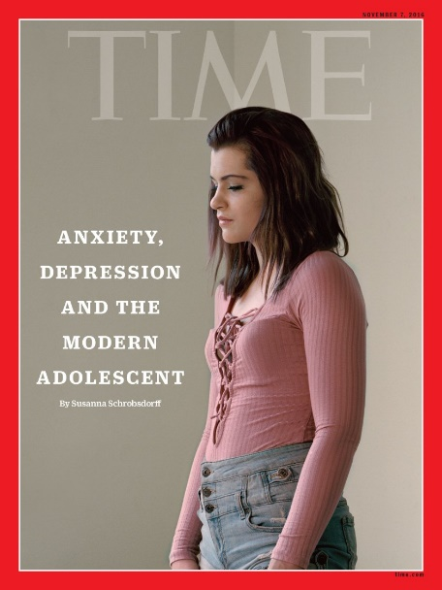
“# Feeling Blessed,” seems to be the new bragging expression nowadays.
Now, don’t get me wrong, there is nothing wrong with feeling blessed. On the contrary, being conscious of your blessings; of the way God, destiny, or good luck touched your life, is a blessing in itself. The problem arises when we feel the social imperative to share such consciousness of feeling blessed with everybody without distinction, all the time, 24/7.
It seems that our shared lives cannot be anything less than perfect. The truth, however, is that, no matter how blessed I feel, and how good my life is, my life is not pristinely perfect.
I don’t spend every day of my life sipping a margarita on a Caribbean Island; my parents have health problems; although I believe I am a good husband, a good father, and a good son, I am sure Silvia, my children and my parents will tell you that there is room for improvement, and to add the cherry on top of my imperfect life, I was told by a few shul members that I will never become a golf pro.
My father recalls a story about “tia Golde,” a rich great aunt and actually the only rich member of his extended family. When “tia Golde” came to visit, my bobbe and my zaide, spent days cleaning and tidying the house to make it presentable for the illustrious visitor. My father was grateful that “tia Golde” came to visit –she always brought gifts with her- but he was also grateful that she came to visit only once or twice a year. After all, having an impeccable home, an amazing job, perfect children, and a pristine life all the time, 24/7, can be very exhausting.
The Torah, and Jewish texts in general, present us with a very different model, one that I wish to share with you and that you might wish to explore.
Our Biblical heroes not only aren’t gods or demigods, like in Greek and Roman mythology, but they are even too human.
Abraham, Sarah, Isaac, Hagar, Ishmael, Hanna, and Eli the Priest, just to mention the Biblical characters in the Rosh Hashanah readings, live complex lives filled with hope, love, and devotion, but also with anger, jealousy, fear, resentment and intolerance.
On God’s Instagram, his devoted patriarchs, matriarchs, prophets, priests, and kings, do not live perfect lives and are not smiling 24/7.
On God’s Facebook page we won’t see Abraham and Sarah sharing a meal with Hagar and Ishmael. On the contrary, on God’s Facebook page, Moses’ job sucks, David’s family is a mess, Prophet Elisha has serious anger issues, Rachel and Leah experience sibling rivalry, and righteous Job spends his days and nights experiencing loss and suffering.
Couldn’t God have written a holy book filled with just happy stories with happy endings and flawless characters? I am sure He could have. But He chose not to.
I like to believe that God, on purpose, chose to share the complex lives of His Biblical heroes to teach us that it is OK to have complex lives. Being exposed to Moses’ frustration, to Elisha’s anger, to Job’s suffering, to Abraham’s fear, to Sarah’s jealousy, and to Hannah’s sadness, should remind us that it is OK to feel frustration, anger, suffering, fear, jealousy, and sadness.
What a sad society is one in which its members can only share their happy moments, in which we must always be seen as successful and fulfilled, loved and loving, peaceful and cool.
What a pitiful waste of energy and resources to live our lives for people who don’t care for us and we don’t actually care for them, instead of spending quality unadulterated time, non-mediated by electronic devices, with our loved ones, with our inner self, and with God.
The Torah doesn’t care for only happy stories with flawless characters, living perfect lives. The Torah is a tree of life, and as such deals with real life stories, like yours, like mine.
The truth is that God doesn’t like perfect lives. In a perfect life there is no need for kindness or for compassion; in a perfect life there is no growth, no room for prayer or yearning; in a perfect life there is no need for God.
And so we pray:

Master of the Universe, help us embrace our imperfect lives so we can find room for growth and change, and ultimately find You. May we be surrounded by a few true good friends, who will love us despite our imperfections, who don’t need to see us smiling 24/7. May we find the strength and courage to share the not-so-pretty aspects of our lives, our pain, our anger, our frustration, and our sadness, the same way we share our “perfect social lives.”

Bring down the barriers of shame and awkwardness that prevent us from being more genuine, less phony, humbler, and less deceptive. Today, on the Day of Judgment, we ask your help to become more embracing, less judgmental, more inclusive.

May this year be one of health, comfort, kindness and compassion. May all of us and our loved ones be blessed with a healthy, peaceful, joyous, and sweet year. Amen.

My Perfect (Social Media) Life, by Iaremyne. In http://iaremunyee.com/my-perfect-social-media-life
By Jade, in: https://www.elitereaders.com/social-media-obsession/
https://www.yourhealingandhappiness.com/blog/127-how-social-media-increases-anxiety-depression-in-kids See also: http://time.com/magazine/us/4547305/november-7th-2016-vol-188-no-19-u-s/
You may wish to check these youtube videos which address the pathological need of sharing perfect lives on social media and its consequences. https://www.youtube.com/watch?v=MpQxM5OFE60 https://www.youtube.com/watch?v=FLrWdfwWNK8 https://www.youtube.com/watch?v=0EFHbruKEmw https://www.youtube.com/watch?v=GXdVPLj_pIk https://www.youtube.com/watch?v=G8VoCbvvthk https://www.youtube.com/watch?v=tFrvKc30Iqw
Ibid.

