Rabbi Kogan is Going to School!!
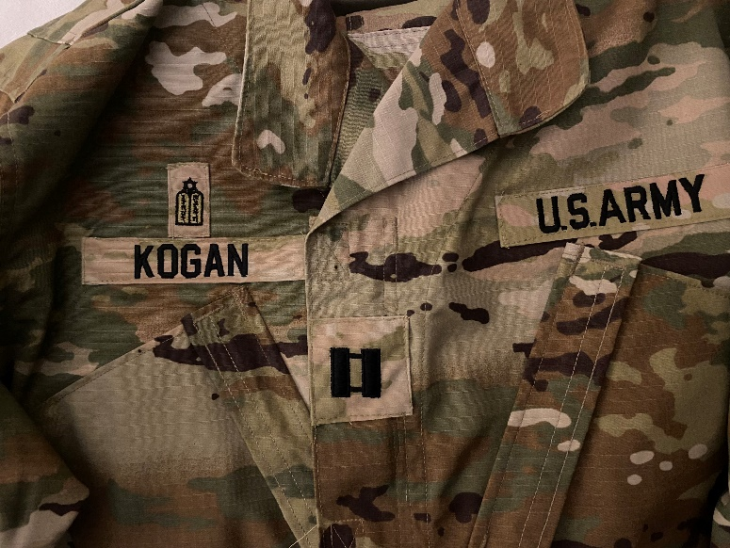

Dear Friends of Hillcrest Jewish Center,
A little over a month ago I told you about my new journey in life as a military chaplain.
My first drill will take place in October and that is when I actually begin to serve and hopefully to make a difference. I received my uniform and my military ID, and my last name and rank have already been sewn onto the uniform (see picture). For me, the most exciting feature of my new uniform is the small Tablets of the Law above my name. That tells everyone that I am not only a Chaplain, but a Jewish Chaplain. If you pause for a minute and reflect on the fact that the U.S. Army has an official distinctive insignia for Jewish Chaplains, you will have to conclude, as I do, that we are very blessed to live in the United States of America.
The other exciting and somehow anxiety-provoking news related to my new journey as a U.S. Army chaplain is that I need to go to Chaplain School. As you can imagine, like most of you, I haven’t been in school in a while. Being a rabbi is a life-long learning experience, but beginning on January 19, 2023, I will be attending Chaplain School with about 60 other army chaplains from all over the United States – a few other Jewish ones, most of them not. Chaplain School takes place at Fort Jackson, South Carolina. Fort Jackson is the U.S. Army's main production center for Basic Combat Training. Each year the installation trains roughly 50 percent of all soldiers and more than 60 percent of women entering the Army. Chaplain School lasts three months, and while you can break it down, I will be doing most of it between January 19 and March 28, 2023.
While Chaplain School trains the chaplains in pastoral skills (something I humbly hope I am good at by now), the main purpose of the school is to expose the religious leaders who will serve in the U.S. Army to the Army itself, its culture, its many rules and regulations, its history, and its distinctive language, including countless acronyms like DOD, AT, TY, DFAC, MRE, and many more. I will be sitting in a classroom, taking notes, and learning new stuff. I also learned from another rabbi who was there a year ago, that Chaplain School involves PT (Physical Training) every day beginning at 4:30 AM. I also know that I will be the oldest student in the class, hence my understandable anxiety.

Having said so, there is an extra motivation in me going to Chaplain School, and that is to show my children and my congregants that it is never too late to learn something new and to take on new challenges. I tell my adult children with a sense of pride, “Abba is going to school!” And I tell all of you as well, with the same sense of pride, “Rabbi Kogan is going to school!”

The HJC leadership and I will start working on a plan for the little over two months that I will be away. The plan will include our wonderful and skillful lay-leaders and hopefully, visiting rabbis, cantors, or rabbinical students. Stay tuned.

This new journey of mine represents an adjustment for me and for my family.
While the time I will take off to go to Chaplain School and to fulfill my new Army obligations is contemplated in my contract, I am aware that it will still require some adjustment for you as well. I thank you in advance for your good will and flexibility. Perhaps you may want to think that while I am away serving, by keeping our shul vibrant and energetic, you are serving with me.

Last but not least, since we are still in our main holiday season, let me wish all of you a Gmar Chatimah Tova, Chag Sameach, and a good and sweet year.

Rabbi Manes Kogan

