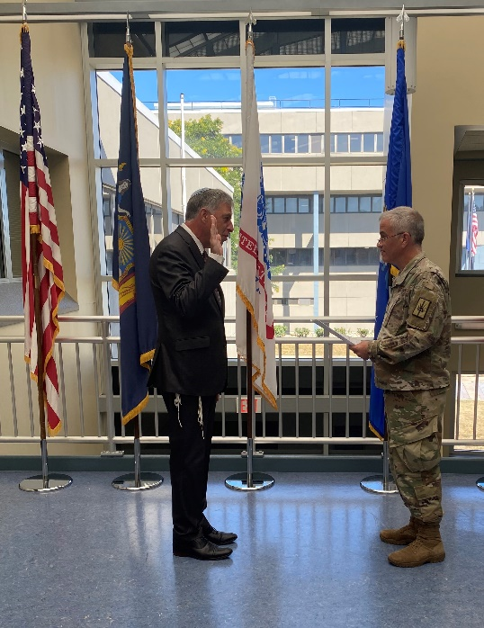
Dear Friends of Hillcrest Jewish Center,
Since as early as I can remember, I was interested in the military. I believe that discipline and order are good character traits to develop, and that structure is necessary for creating a sense of stability and balance in our lives.
Growing up in Argentina, any thought of joining the military in any meaningful way was out of the question. First of all, the armed forces in Argentina have been responsible for one of the darkest periods in Argentinean history; and second, Jews are not welcome in the military, which has a well-earned reputation of being antisemitic.
When I moved to Israel to finish high-school there (a story for another time), I considered joining the IDF and I even went to pre-army information sessions, but I was studying there by myself, without my parents, and finally decided to return to Argentina to be with my family and pursue my studies.
A year and half ago, I was talking with a colleague of mine, Rabbi Joel Levenson, from the Midway Jewish Center; he told me that he was applying to join the National Guard as an army chaplain and that got me curious. He put me in touch with a couple of people and I started a long application and selection process that took literally one and half years. In that year and a half, I needed to pass a physical test, get my academic credentials validated, pass an English test, be fingerprinted at West Point, obtain an ecclesiastical endorsement, and sign countless papers, including an age waiver.
Finally, yesterday, I traveled to Albany where I appeared in front of a military certification board (one colonel and two lieutenant colonels), who, after examining me, welcomed me into the United States Army, where I will serve with the rank of Captain. I was sworn to uphold the United States Constitution (see picture), signed more papers, and was treated to a vegan lunch, together with my family, by Chaplain Brock and Chaplain Miller, the two New York State head chaplains.
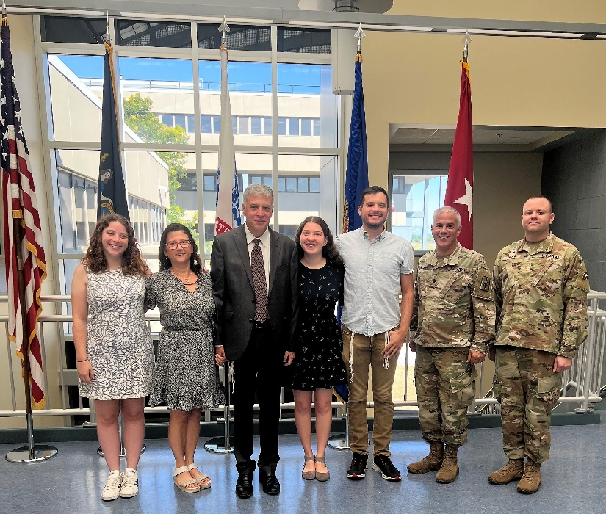
It goes without saying that I am very excited by this new challenge, which will allow me to make a difference in the lives of the soldiers in my unit, to use my pastoral skills and experience in a new setting, and to give back to this country that welcomed me and my family with open arms.
In a few days, I will receive my military ID and uniform, and get ready for my first drill.
I believe that my new involvement with the US Army won’t take away from my full commitment to Hillcrest Jewish Center as I am confident that the drills won’t interfere significantly with Shabbat and Jewish holidays (the National Guard was able to accommodate many other rabbis before me). I will have to go through a modified version of basic training for chaplains (I better start getting fit, no Shabbat cake for me – okay maybe just one piece) and I expect that the time needed for drills and training will come out of my learning and sabbatical time allocated in my contract.
In the coming weeks, Silvia and I look forward to sponsoring a Kiddush to celebrate this new accomplishment with you and to show you how handsome I look in my new uniform.
While I have some questions myself about this new chapter in my life, I hope and pray it will not only make me a better US citizen, but a better rabbi. My family is very proud of me and I hope to make all of you proud, as well.
Many blessings,

Rabbi Manes Kogan

