Dear friends of Hillcrest Jewish Center,

Blogger Sara Finnan writes in her blog, Lovin Dublin, “Widely considered to be the gold standard of family adventure movies, Back to the Future is one of those rare gems that is loved by all. Whether you're into science fiction or not, there's something extremely likeable about Marty McFly and it's hard not to rate the onscreen dynamic between him and Doc.

Packed full of wisdom, fans have always delighted at quoting the movie, but one quote, in particular, has taken on added significance this year - that being Doc's advice to Marty, which Dublin artist Emmalene Blake has used as fodder for her latest mural.

Immortalizing the film's main characters in paint, the mural pictures the duo alongside the words: Whatever happens Marty, don't go to 2020!”

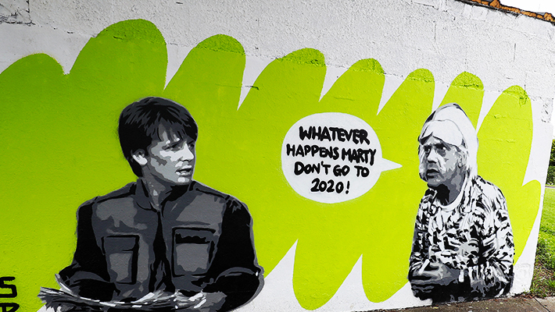

Indeed, 2020 will be remembered by most people living on Earth as a year better forgotten.

People have challenges thinking and reflecting about their own times, and yet, we can guess probably correctly that 2020 will be a year people will talk about as a before and after. The Covid-19 pandemic, which widely affected directly or indirectly every human being on planet Earth, touched our lives and affected the way we communicate, we study, we work (or don’t work), we love, and we pray.

One of the lesser known Rosh Hashanah blessings – perhaps because it is more difficult than L’Shanah Tova – comes from a medieval poem, which is in turn based on a Talmudic statement:

תכלה שנה וקללותיה, תחל שנה וברכותיה
Let the year end and its curses, let the year begin and its blessings.

Undeniably, there is a shared feeling that we had enough, that this craziness must end soon, that children should be able to visit their parents in nursing homes, that classmates should be able to share a room and not just a screen (thank God and smart people for technology), and that congregants and friends should be able to gather around a Kiddush table and have a real bagel with tuna (look what we have come to wish for) and not just virtual greetings.

For many of us including myself, in addition, this year has been a year of personal pain and loss, pain and loss increased by the inability to mourn properly and to be hugged and kissed by the people we love.

One of the advantages of being Jewish is that we don’t have to wait for December 31, 2020 to say: Let the year end and its curses, let the year begin and its blessings. Rosh Hashanah is around the corner and we can use these coming days of prayer and reflection to ask Hashem to grant us a Shanah Tovah, a good year. Good is actually underrated, but who wouldn’t take good right now? Who wouldn’t settle for a “plain vanilla” good year, without masks, without social distance, without so much illness, pain, and death?

Let the year end and its curses, let the year begin and its blessings. The optimist in me tells me that things will get better, hopefully soon.

Silvia, Daniela, Ilan and Abby join me in wishing all of you and your loved ones a sweet and good year.

Rabbi Manes Kogan

https://lovindublin.com/dublin/dont-go-to-2020-sound-advice-from-dublins-newest-back-to-the-future-mural

